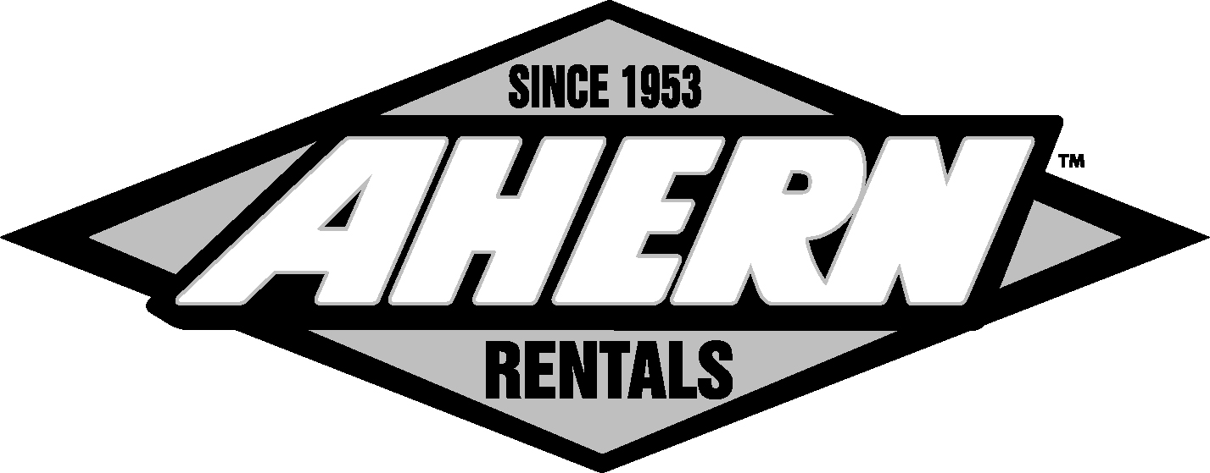
Employee Recognition Survey

Mark the top five ways you would like to be appreciated. |  |  |  |  | Fill in the blanks with your favorites.
 | Handshake/Pat on the back |  |  |  | My favorite color is
 | Handwritten note |  |  |  | My favorite TV show is
 | Name in our news letter |  |  |  | My favorite movie is
 | Gift certificate/Card |  |  |  | My favorite flower is
 | Company-branded merchandise |  |  |  | My favorite ice cream is
 | Ribbon |  |  |  | My favorite movie rental store is
 | Balloons |  |  |  | My favorite sports team is
 | Button |  |  |  | My favorite book store is
 | Company dollars/Discount |  |  |  | My favorite musical group is
 | Time off with pay |  |  |  | My favorite US city is
 | Buy me lunch |  |  |  | My favorite hobby is
 | Movie tickets |  |  |  | My favorite board game is
 | My house professionally cleaned |  |  |  | My favorite candy is
 | Announcement made in a meeting |  |  |  | My favorite author is
 | Round of applause |  |  |  | My favorite restaurant is
 | Certificate of thanks/achievement |  |  |  | My favorite foreign city is
 | Chocolate bar |  |  |  | My favorite breakfast food is
 | Gift basket |  |  |  | My favorite mall is
 | Flowers |  |  |  | My favorite outdoor activity is
 | Praise from top management |  |  |  | My favorite fruit is
 | Time off without pay |  |  |  | My favorite clothing store is
 | Donation to charity in your name |  |  |  | My favorite department store is
 | Money |  |  |  | My favorite business book is
 | Announcement in office memo |  |  |  | My favorite charitable cause is
 | Manager does my job for one hour |  |  |  | My favorite party spot is
 | Name and picture on board |  |  |  | My favorite coffee/tea is
 | Other: |  |  |  |  | Other:
Employee Name: |  |  |  |  |  |  |  |  |  |  |  |  |  |  |  |  | Date:

